CBT driven Chatbot with Seq-to-Seq model for Indian Languages

¹Subhash Tatale, ²Nivedita Bhirud, ³Priyanka Jain, ⁴Anish Pahade, ⁵Dhananjay Bagul, ⁶N. K. Jain
^{1,2} Assistant Professor, Computer Engineering, Vishwakarma Institute of Information Technology, Pune, Maharashtra, India
³Associate Director, Artificial Intelligence Group, CDAC, Delhi, India
^{4,5} Student, Computer Engineering, Vishwakarma Institute of Information Technology, Pune, Maharashtra, India
⁶Senior Director, Artificial Intelligence Group, CDAC, Delhi, India

ABSTRACT

Chatbots, also known as conversational interfaces, provide a new way for people to interact with computer systems. A chatbot software is a feature or an application to communicate directly through a natural language with online users to have their query to be solved. In a way, the Chatbots are being taken as a virtual assistance of the user, with whom they can interact smoothly.
The World Health Organization declared COVID-19 as a Public Health Emergency of International Concern. The consequences of COVID-19 impact not only physical health and wellbeing but also mental health, which can have a disastrous effect on the health system. This CBT driven Chatbot in development provides frequently asked questions of COVID-19, information resources concerning COVID-19. Additionally, the Chatbot offers a mental Patient Health Questionnaire test to the user. Based on his sentiment analysis score, the user can find and resolve COVID-19 related issues and mental disorders like sadness and depression.
There were many challenges encountered while building a Chatbot in Indian languages. No appropriate data and information in Hindi language related to COVID-19 and mental health was available. Therefore, maintaining and addition of data in the database was a tedious task. Being morphological rich free word order language, Indian languages carry ambiguities and complexities and subsequence these are complex to handle. Most of the Indian languages fall under low resource language category as the datasets currently available for most Indian languages were small when compared to the English language.
After extensive and vast research on the topic, we found that the development of a Chatbot in the Indian language was very important and necessary which would help people who know only Hindi Language to converse with the Chatbot easily. Natural Language Processing (NLP) is the technology at the heart of the Chatbot's rise. Recent advances in Machine Learning (ML) have greatly improved the accuracy and efficacy of NLP, making Chatbots a viable option for many organizations. This Chatbot begins its service by collecting relevant data from the user and then displays the results in the web and mobile versions. This CBT driven Chatbot is built using the Transformer model architecture, which is based on the Attention Mechanism. Previously, the authors worked on this model for the English Language, and now to advance and evolve the Chatbot in different languages, the authors are developing the Chatbot in the Hindi Language in addition to the English Language. We have applied Seq-to-Seq transformer based Deep Learning model into proposed work which presents an end-to-end potential work in the domain.

Key Words: Artificial Intelligence, Chatbot, COVID-19, Mental Health, Natural Language Processing, Natural Language Understanding, LSTM, Sequence to Sequence, RNN, Attention Mechanism.

- INTRODUCTION

According to the World Health Organization (WHO) survey, more than 300 million people are suffering from depression, and about two-fifths of the population suffers from common mental ailments due to the lockdown and the ongoing COVID-19 epidemic [26]. One of the best ways to relieve depression is interacting, but due to fear of being judged most sufferers avoid interacting [1]. Therefore, Chatbots came into the picture, and hence the potential of Chatbots to provide assistance and answers to queries and questions by users is an interesting proposition and has great potential. Chatbots are one of the latest inventions of digital design after the rise of the web and mobile apps.

Chatbots help to reduce pressure in health systems and are being implemented all over the world, and they can be used as a reliable source of information by professionals in the field to avoid problems with self-medication or the general collective panic [23]. Chatbots are also known as computer-programmed conversational agents. There is also a type of Artificial Intelligence (AI) interaction between users and machines via Natural Language Processing (NLP). The growing popularity of chatbots is also due to their efficiency in terms of cost savings by replacing human assistants, increasing user satisfaction by shortening response times, and being available 24 hours a day.

Chatbots are intelligent systems that can converse with humans and provide answers using natural language. Chatbots that can reason and learn can scale much faster than human personnel [17]. The Chatbot accomplishes this by comprehending and responding to the user's inquiries.

The Encoder-Decoder model using Recurrent Neural Networks (RNN) that uses multiple iterations for processing an intermediate state is the most common word in all NLP text generation models. Overall, the use of NLP and ML in domain-specific chatbots improves their ability to understand what humans want to say and, as a result, provide more accurate responses [15]. Computers can perform a variety of tasks using NLP, including knowledge extraction, sentiment analysis, speech recognition, and fake news detection [19].

As India has a population of more than a billion, this CBT driven Chatbot will help to manage the rush of those seeking medical care. Thereby reducing the high number of walk-ins to hospitals by those who suspect they have been affected by the virus. To provide additional support in mental health treatment, the Chatbot intends to help COVID-19 patients and people's mental health from the comfort of their own homes 24x7. The proposed system also includes a preliminary COVID-19 test in which the user can check for COVID-19 symptoms and their intensity by answering specific questions. The proposed system employs a user-friendly interface based on mobile technology to reach the maximum possible audience and in the future may implement it in web applications and expand it in further different languages.

A Chatbot is executed using pattern comparison, in which the sentence order is recognised and a saved response pattern is adapted to select sentence variables. Chatbots are primarily developed as a conversational interface engine written in Python, allowing them to respond based on collections of all known conversations [2]. The Hindi language is used by this chatbot system using the Sequence-to-Sequence model [4]. This is based on an RNN-based Encoder-Decoder framework which is one of the most commonly used models for Chatbot development. The Encoder and Decoder components make up the Sequence-to-Sequence model. The Encoder accepts source text as input and processes it to generate a thought vector, which is an intermediate representation of the input text. The thought vector is then fed into the Decoder input unit. The Decoder now processes the thought vector and generates outputs [16]. One key challenge with Sequence to Sequence (as in other neural network models) is that there are so many settings and hyperparameters that need to be tuned to get a good performing working model [3].

This proposed work is organized in different sections. Following the introduction to the topic, Section-2 deals with the Literature Survey done on the topic where the authors referred to some important research papers and web resources. Section-3 discusses works related to the proposed system. Section-4 describes the overall architecture of the proposed system and provides details about the components and sub-sections of the CBT driven Chatbot. Section-5 displays the implementation of the Chatbot and provides details about the internal working of the Chatbot. Section-6 concludes the entire project with the result and discusses future possibilities for improving the effectiveness of the system.

- LITERATURE SURVEY

Chatbots, which connect patients with healthcare providers, healthcare information, and treatment, play a role in finding more efficient ways to provide timely medical care, access, and quality treatment to patients. The creation and execution of chatbots is still a developing field that is heavily influenced by AI and ML. The authors attempted to survey the Chatbot's related topics in this section.
A parametric comparative review of a survey done on 18 research papers is mentioned in Table 1 below,
Sr No. | Paper | Year | Observation/Final Outcome | Technology used | Interface provided
1. | Chatbot for Depressed People [1] | 2021 | Helps to overcome depression | Seq2Seq, LSTM | Chat interface
2. | Chatbots for Multilingual Conversations [20] | 2019 | Multilingual chatbot in actual conversation using different languages | Microsoft Visual Studio | Tutor Mike Chatbot
3. | DoctorBot - An Informative and Interactive Chatbot for COVID-19 [19] | 2020 | Developed a Chatbot based on COVID-19. | AI, NLP | Chat interface
4. | Conversational Assistant based on Sentiment Analysis [22] | 2019 | The user can provide input either through text or speech.  The proposed model also fetches the latest tweets of the user using the Twitter API. | Seq2Seq model | Web interface
5. | Digital Psychiatry – Curbing Depression using Therapy Chatbot and Depression Analysis [27] | 2018 | Specifies depression levels and suggests treatment on the basis of it. | ML and NLP | No interface
6. | Review of Chatbot System in Hindi Language [2] | 2019 | Chatbot is designed for a normal question-answer interaction in hindi language. | Python, Pattern Matching | Chat interface
7. | Mental Health Monitoring using Sentiment Analysis [11] | 2020 | The authors discuss the use of mining or extraction of data from various sources such as SmartPhones, Wearable Gadgets (Smart Watches) and Health Trackers (Fitness Tracker Bands) and proposes a model using Lambda Architecture to analyses the extracted data to predict the mental state of the user maintaining user secrecy and data privacy. | Sentiment Analysis, NLP | No interface
8. | Seq2Seq AI Chatbot with Attention Mechanism [8] | 2020 | A training model is trained for three different conversations. After that they are compared with a baseline Seq2seq model. A basic conversational chat interface is created. | RNN, Seq2Seq, Python Flask app | Web interface
9. | Review of Chatbots Design Techniques [7] | 2018 | The authors reviewed several types of Chatbots used for multiple purposes such as for businesses, marketing, education, etc. The reviews have covered several papers that have focused on Chatbot design. The review provides  explanations on Chatbot’s design in today's market.. | AI-ML, Pattern Matching | No interface
10. | A medical Chatbot [9] | 2018 | Created a system that allows users to submit complaints and questions about their health. The primary goal in developing this system was to ensure customer satisfaction. The actual benefit of the Chatbot is to assist people by providing proper guidance on good and healthy living. The system is beneficial for medical institutes or hospitals because it allows users to freely ask medical dosage-related questions via voice. | NLP, Support Vector Machine (SVM) | Mobile application
11. | Conversational AI Chatbot Based on Encoder-Decoder Architectures with Attention Mechanism [6] | 2019 | The authors used modern techniques to create a Conversational AI Chatbot. They created an Encoder-Decoder attention mechanism architecture. An RNN with LSTM cells is used in this Encoder-Decoder. The attention mechanism enables the decoder to selectively examine the input sequence while decoding. | Encoder-Decoder, Attention mechanism | Chat interface
12. | Survey on the Design and Development of Indian Language Chatbots. [13] | 2021 | Developed a Chatbot with the conviction that Chatbots in Indian languages can be used to enhance communication between Indian users. To operate effectively, the chatbot must have access to a lot of logical resources. The authors thoroughly investigated the methodologies and behaviour patterns of various Indian Chatbots and compared their accuracy. | NLP | Chat interface
13. | Smart Ubiquitous Chatbot for COVID-19 Assistance with Deep learning Sentiment Analysis Model during and after quarantine. [5] | 2020 | This Chatbot is developed for the help of patients during and after the COVID-19 quarantine period. | NLP, LSTM | Web interface, Mobile application
14. | Medbot: Conversational Artificial Intelligence Powered Chatbot for Delivering Tele-Health after COVID-19 [12] | 2020 | The application reduces the barriers for access to healthcare facilities and provides information and advice to chronic patients. The authors propose a conversational Chatbot “Aapka Chikitsak”. | NLP, Google Cloud | Mobile application
15. | Grammar checkers for natural languages: a review [10] | 2017 | Conducted a descriptive study of various grammar checks for global languages as well as some Indian languages such as Hindi, Urdu, Punjabi, and Bangla. The authors examined various grammar checking approaches and methodologies, as well as key concepts and grammar checker internals. | NLP | No interface
16. | Chatbot using a knowledge in database: human-to-machine conversation modeling. [3] | 2017 | Developed a Chatbot in such a way that each of the patterns is paired with Chatbot knowledge that has already been processed from various sources. sentence similarity is calculated using bigram, which divides input sentences into two letters of the input sentence. The data is modelled after the conversation, and the results with the Chatbot are investigated. | NLP, Bigram | Chat interface
17. | Multilingual Healthcare Chatbot Using Machine Learning. [4] | 2021 | The Chatbot application converses with the user using concepts of NLP and also supports speech to text and text to speech conversion so that the user can also communicate using voice. Five different ML algorithms have been analyzed for disease prediction. The Chatbot supports three languages namely English, Hindi and Gujarati. | NLP, ML | Chat interface
18. | Adaptive Machine Learning Chatbot for Code-Mix Language (English and Hindi). [15] | 2020 | Implementation of NLU and ML algorithms in the chatbot system being implemented made it smart and user friendly to make it behave as a virtual friend. Also, algorithms used in the Chatbot makes it more efficient, as if it looks like not a virtual system but a human that you are talking to. | NLU, NLG | Chat interface
Table 1: Parametric Comparative Literature Review

In this research paper, the reviews have been covered from several papers that have focused on different research work carried out for developing Chatbot. After the extensive survey done on the topic and related data, it is found that there is no significant CBT driven Chatbot, or related project done with the Hindi (Indian) Language. This CBT driven Chatbot offers a vast variety of options such as a Frequently Answered Questions (FAQ) on COVID-19 and Mental illness, a Patient Health Questionnaire (PHQ-9) test to check the early symptoms of illness, and assistance by a Virtual Avatar compiled altogether in one application. Therefore, the authors extended the work for the Hindi Language which was previously performed by the authors in the English Language.

- PROPOSED WORK

There is an increase in the number of cases of mental stress, severe illness, and other related disorders due to the COVID-19 lockdown situation throughout the globe and to address this situation, the authors proposed a CBT driven Chatbot system for immediate assistance. The proposed Chatbot has a well-designed architecture with a structured knowledge engine to provide an intuitive interface. The Chatbot also offers mental health counselling and self-assessment exams for mental illnesses, in addition to coronavirus information. The Chatbot is designed for an easy self-check for the symptoms of COVID-19 and mental illness. All the important data for answering the question is available in the database from which the Chatbot will match and display the result according to the question asked. The input is compared with the inputs saved in the database and a matching response is returned. The Hindi language is used to interact with users.
COVID-19 testing and providing mental assistance to people without physical interaction is essential. Hence, the authors proposed a contactless CBT driven Chatbot system. This Chatbot design includes a software algorithm that produces responses based on given input to simulate human conversations in voice or text mode. The Chatbot offers users to have a conversation with the voice-chat input feature and then get a system-generated text output. Along with the voice chat option, this Chatbot also has a feature of Virtual Avatar which acts like a human assistant and has its different features.

3.1 Flow of the system:
The proposed COVID-19 Chatbot is described in this section. Chatbots can be observed everywhere, replacing website queries and FAQs as well as providing virtual assistance. The authors proposed contactless communication through a Chatbot system. Using a sequence-to-sequence network with a many-to-one framework will take the different kinds of symptoms. These different kinds of symptoms would be considered as many inputs as possible and based on the many inputs a single output would be generated.

This section explains the flowchart of the proposed system. Figure 2 depicts the same.

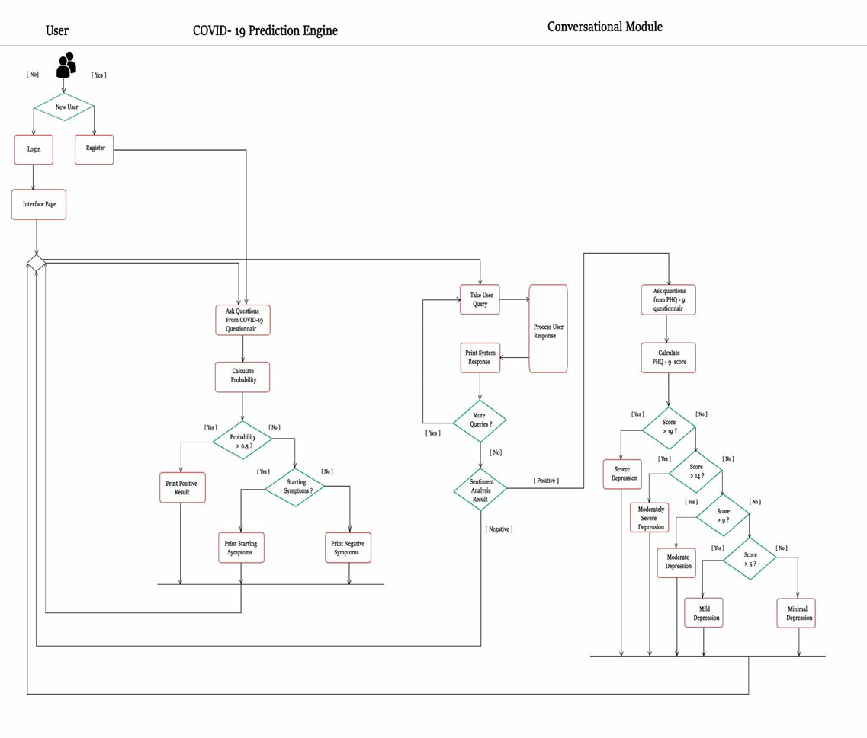
Figure 2: System Flowchart
- User Registration: To ask the queries and to access all other features of the Chatbot, the user will have to go through the process of registration and login first. Figure 2 shows the representation starting from a user registration followed by login and transfer to the Interface page where he/she can ask the query to the Chatbot and calculate the probability of having COVID-19.
- COVID-19 Test: A COVID-19 testing system is one of the features the authors included in the Chatbot application. The test is developed to predict if the user has the symptoms of COVID-19 or not. The COVID-19 test consists of five questions, all are yes or no questions. These questions are based on the general symptoms of COVID-19. After answering all of the questions, the user will get to know whether he is holding any possible symptoms of COVID-19 or not. This COVID-19 test produces the best results possible according to the user's answers.
- PHQ-9 Test: The PHQ-9 is a new instrument for making criteria-based diagnoses of depressive and other mental disorders commonly encountered in primary care. The PHQ-9 is a reliable and valid measure of depression severity. It is not a screening tool for depression, but it is used to monitor the severity of depression and response to treatment [21].

Each of the questions has a score ranging from 0 to 3 on the PHQ-9's depression module and there are 4 options to answer these questions:
1. Nearly every day
2. More than half of the days
3. Several days
4. Not at all

Based on the question answered and the score achieved after having the PHQ-9 test, the final score is calculated and then the user can know the severity of the depression.
- If Score more than 19 - Severe Depression
- If Score less than equals 19 - Moderately Severe Depression
- If Score less than equals 14 - Moderate Depression
- If Score less than equals 9 - Mild Depression
- If Score less than equals 4 - Minimal Depression

3.2 Architecture

Having a good balancing of cohesion and coupling, the modular architecture of Chatbot is organized in three major sections:
i. COVID-19 Prediction Engine
ii. Conversational Module
iii. User Interface and Virtual Avatar Specification

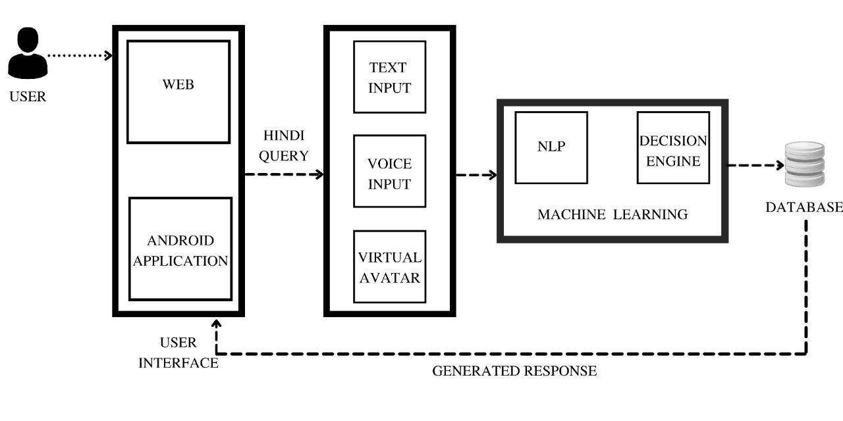
Figure 1: Architecture of Chatbot System

i. COVID-19 Prediction Engine: After successful login, the authorized user from the interface page will take input as the user query and process the response and print the system response. Chatbot users can self-evaluate his/her symptoms of coronavirus. The proposed test is a simple COVID-19 symptom checking test that allows people to investigate their symptoms on their mobile applications. It is basically a short questionnaire that asks people about various primary and significant corona symptoms and then displays the test results based on their responses. The questions are to be answered: "yes" or "no".
ii. Conversational Module: A simple messaging interface is used to communicate with the Chatbot, and it is designed in similarity with most other messaging apps with an easy-to-understand interface. As a result, the user does not need any special knowledge or skills to use it. The user can have the conversation in the Hindi Language. The goal of chatbots is to mimic human dialogue in order to provide the most intuitive user interface for applications or, in some cases, to simply provide entertainment [20].
iii. User Interface and Virtual Avatar Specification: The interface aims to provide easy and smooth interaction with the Chatbot without expertise for all the users. The application comes with an easy-to-learn and use interface. The interface is also in charge of displaying the user's system-generated results. As a result, the chat interface can be considered the system's face, through which all communication takes place. It acts as a liaison between the system and the user [24].
The virtual avatar is a three-dimensional (3D) human model that enables more human interaction through the audio input. Avatars are visual representations of real or artificial intelligence in the virtual world. They have the appearance of humans, human-like (often animated) characters, or other living creatures. Using audio input, the user can simply ask a question. The 3D model plays a talking animation after the Chatbot creates an answer, and the answer is presented using Text-To-Speech technology.
Since, it is different for virtual avatars and chatbots, when it comes to digital avatars, in particular, the working of conversational AI is pretty similar to chatbots, apart from a few added things. A physically-embodied human provides a more immersive experience than a Chatbot because you can see the avatar visually. A virtual avatar talks with the help of expressions and gestures, which gives users a very personalized experience.
The user can utilize the messaging interface or the virtual avatar to communicate with the Chatbot. This virtual avatar was developed for the English corpus and now will be updated with the new changes with the Hindi corpus. There are a total of 6 avatars designed to have a choice for the user as –
Male,Female,Child Male,Child Female,Old Male and Old Female
The avatar design is enriched with some different animations and responses. Some of the essential animations were acquired from the Mixamo website. Blender was used to create these models and setups, and animations are baked in a specific order. Each avatar has three animations, as Idle,Talking and Waving
The talking animation would be activated when the Chatbot generates an output. Call backs are used to transition between these animations. For interactivity, the virtual avatar interface uses void input and output. The user's voice is captured using the Speech-To-Text service using the Speech-To-Text API of Google. The user's voice inquiry is decoded and returned in text format using this API.

4. IMPLEMENTATION

In this section, the implementation details and important modules used in the proposed system are given.
- Data Deception / preparation:
Currently, all the data is entered manually by the user while signing in and giving necessary details such as name and email. But in the future, we can have OTP-based login through mobile number or email which will help us to verify the user and prevent from data deception problems.
- Attention Mechanism:
The basic concept behind trying to implement the Attention Mechanism in the proposed Chatbot is to focus on the specific input vectors of the input sequence depending on attention weights. At each Decoder step, it determines which input parts are more important. In this configuration, the Encoder is not required to condense the complete input into a single vector. The Attention function of the transformer is presented in Figure 3 as a method of calculating the significance of a set of information based on specific keys and queries. The basic Attention mechanism is nothing more than a dot product of the query and the key. The transformer employs multi-head attention layers, which are made up of multiple scaled dot-product attention layers. The scaled dot-product attention function takes three inputs: Q (query), K (key), and V (value) which is defined in the python code as scaled_dot_product_attention (query, key, value, mask).

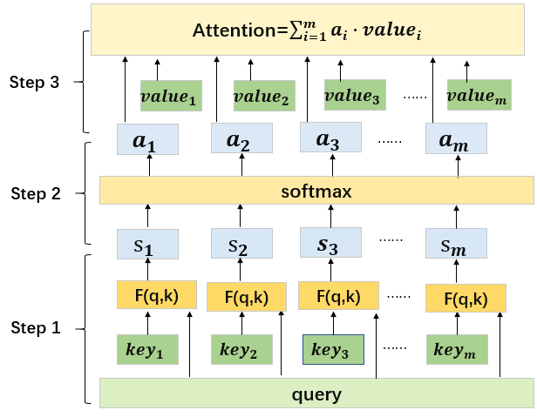
Figure 3: Attention Mechanism

- Sequence to Sequence Model:
The proposed system uses the Sequence-to-Sequence transformer to respond to user requests. This transformer takes a character sequence as input and generates a new sequence based on it. For Dialogue Systems and Machine Translation, the Sequence To Sequence model was chosen as the most reliable model. This model deals with the problem of sequence generation. It consists of two RNNs, an Encoder, and a Decoder. The Encoder takes as input a sequence (sentence) and processes one symbol (word) at a time. Its goal is to convert a sequence of symbols into a fixed-size feature vector that encodes only the important information while discarding the rest. Data flow can be visualized in the Encoder as the flow of local information from one end of the sequence to the other along the time axis. The advantage of using the Transformer model is that the information sequence will not be altered. In addition, this model employs the concept of attention heads, which allows it to store almost infinite amounts of information.

- Encoder-Decoder Framework:
The standard modelling paradigm for sequence-to-sequence tasks is encoder-decoder. The basic task of an Encoder network is to understand the input sequence and produce a lower-dimensional interpretation of it. This interpretation is then passed to a Convolutional network, which produces its own output sequence. This framework is made up of two components, Encoder, and Decoder, both of which were used in our Chatbot.
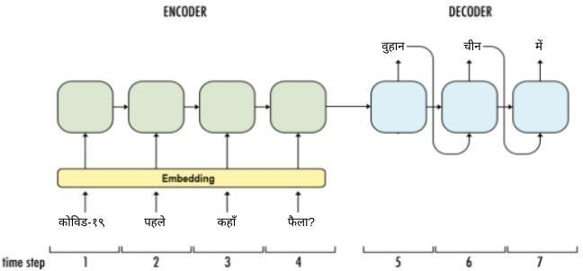

Figure 4: Sequence To Sequence Model
- Encoder Layer - reads source sequence and produces its representation. Each encoder layer consists of sublayers, 2 dense layers followed by dropout. For the Main Encoder Layer, we substituted the values in Encoder Layer as:
Encoder = encoder (num_layers=2, units=512,d_model=128,num_heads=8,dropout=0)
We then used tf. keras.utils.plot_model() to visualize our model. The following figure 5 was generated with the above values in the Main Encoder Layer.
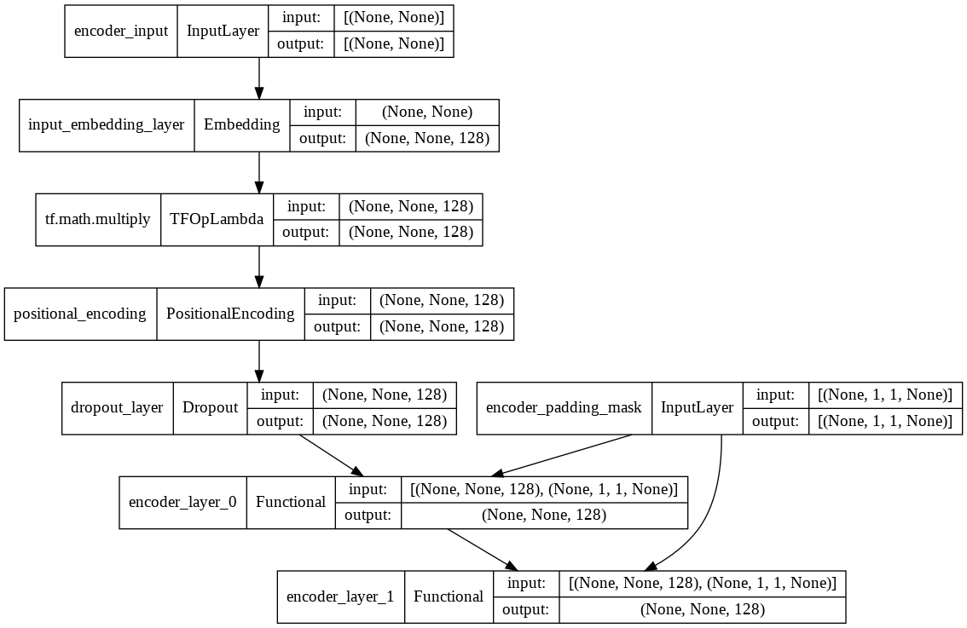
Figure 5: The Encoder Layer

- Decoder Layer - Uses source representation from the encoder to generate the target sequence.
Each decoder layer also consists of sublayers. 2 dense layers followed by dropout. For the Main Decoder Layer, we substituted the values in Decoder Layer as:
Decoder = decoder(num_layers=2, units=512,d_model=128,num_heads=8,dropout=0.1)
We then used tf. keras.utils.plot_model() to visualize our model. The following figure 6 was generated with the above values in the Main Decoder Layer.
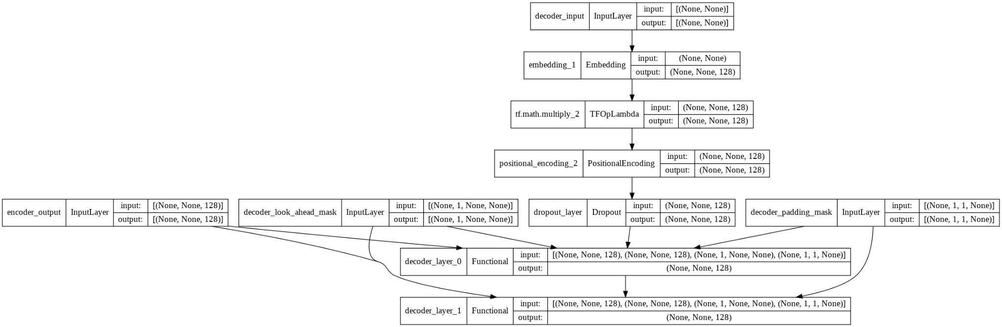
Figure 6: The Decoder Layer
When a source sentence is passed to an Encoder in the backend process, the Encoder encodes the entire source sequence into the context vector. This context vector is then passed to the Decoder, which generates an output sequence in a target language, such as Hindi. The context vector is responsible for condensing the entire input sequence into a single vector.
- Sentiment Analysis:
The user's overall mental state is determined using all the user's inputs to analyze the sentiment. Sentiment analysis has emerged as a significant research area that aids in the discovery of valuable information which can be applied to a variety of purposes. Sentiment analysis is defined in the code as the recognition of the text to be positive, negative, or neutral and get the polarity of the sentence. Sentiment analysis using NLP has been used to predict user information such as mental status, depression, anxiety, stress, etc. According to the output of this module, feedback is given to users i.e Positive, Neutral, or Negative.
The sentiment analysis model oversees detecting the user's emotion throughout the conversation. TextBlob library, which includes built-in classes for analyzing the sentiment of sentences, examines each user input and categorizes it as positive, neutral, or negative. It produces the following values for any sentence: -1, 0, 1.
1: when the input is positive
0: when the input is neutral
-1: when the input is negative
At the end of the conversation of the user with the Chatbot, the user's total sentiment score is calculated. The user is then asked to appear for a depression assessment based on this sentiment score.
In the proposed system, a sentiment score is generated for each user input. The final score of the user is used to determine whether to take the PHQ-9 depression assessment. If the final score is less than 0, the user is required to give the evaluation. Otherwise, the user has the option of giving or not giving the assessment.
e. Chatbot System:
A chatbot is a computer programme that can interact and communicate with human users. Chatbots can make mental health interventions more accessible. Dataset for mental health contains questions that users can ask during the conversation. Chatbot uses a Sequence-to-Sequence transformer for answering user queries. This transformer takes a sequence of characters as input and generates another sequence based on it. Some questions and answers are gathered from an extensive search on the internet. Figure 7 shows a sample interaction between a user and the CBT driven Chatbot.
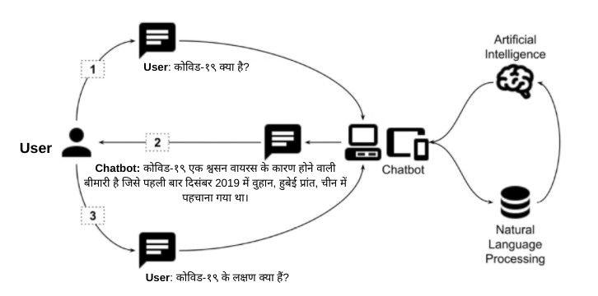

Figure 7: A sample interaction between the user and the CBT driven Chatbot
f. Voice Chat Interface:
This CBT driven Chatbot has the feature of asking a query through the voice input and getting the appropriate answer. The user's voice is captured using the Speech-To-Text service using the speech-to-text API of Google. The user's voice inquiry is decoded and returned in text format using this API. The user's voice is captured using the Speech-To-Text service using the speech-to-text API of Google. The user's voice query is decoded and returned in text format using this API. This text is then sent to the server. The server responds with a textual answer. The response is converted to voice using the Text-To-Speech service.
5. RESULTS and DISCUSSION
Starting from the initial training, the Chatbot progression was trained at several instances to check the overall functionality and accuracy achieved. The data corpus was modified and processed some of the answers accordingly. The length of questions and answers was decreased and again the training accuracy was checked. The below table contains the results of the training accuracy based on the progression of the dataset.
Sr No. | Total Number of rows | Modifications Done | Accuracy
1. | 2500 | Very big and lengthy answers | 0.37
2. | 4500 | Increased the corpus and shorten the length of answers | 0.43
3. | 7000 | Added the mental health questions | 0.47
4. | 10770 | In addition to the Hindi questions and answers, English questions and answers were added. | 0.53
5. | 14263 | Final dataset with questions and answers related to COVID-19, Physical Health, and Mental Health in Hindi and English Language. | 0.63
Table 2: Training accuracy of Dataset
The model may perform better if increased the corpus size and with the addition of processed data. But still, for better accuracy than achieved, more Hindi data needs to be added, and also the sentence length should be shortened accordingly.
Sr No. | Parameters | Output
1. | Vocabulary Size | 8401
2. | Total Questions and Answers in the dataset | 14263
3. | Training accuracy reached | 0.63
4. | Trained on | Google Collab with GPUs
5. | Time is taken per epoch | 12 sec approx
6. | Total time is taken for training | 40 minutes approx
7. | Total Epochs used for training | 153
8. | Loss at the beginning | 5.55
9. | Loss at the end | 0.02
Table 3: Model statistics
The model is trained and tested on Google Collab, and it took approximately 60 minutes to complete the training of about 14263 rows of data. The accuracy achieved was 63% after the completion of training. By including more relevant knowledge base data, the effectiveness of general chat queries can be increased.
The training graph per epoch for accuracy and loss is shown in Figure 8.
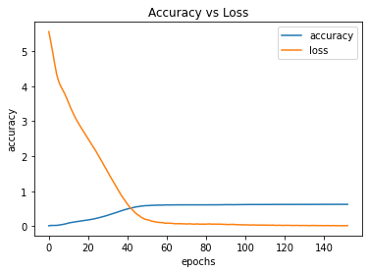
Figure 8: Accuracy vs Loss against epochs
5.1 Training Dataset

Training has been completed on 14263 rows of questions and answers corpus where the categories of questions are from different fields of Coronavirus, mental health, physical fitness, normal infection problems, and other common viruses. Some of the training data to develop this Chatbot was devised from the data available on the WHO website. The complete dataset corpus comprises all the questions and answers in Hindi and English Language.

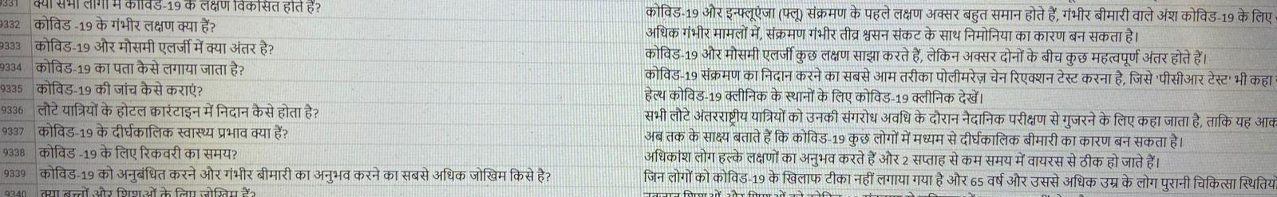
Figure 9: COVID-19 Question and Answers in the Hindi Language
Figure 9 is a representation of some sample COVID-19 questions and answers. The corpus contains all COVID-19-related questions and their answers. It provides all COVID-19-related information, allowing the user to clear up any concerns or ambiguities about the disease.

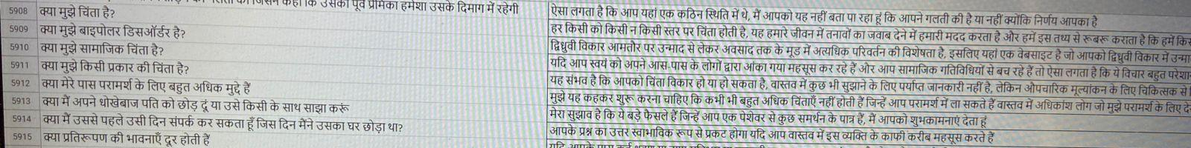
Figure 10: Mental Health Question and Answers in the Hindi Language

Research regarding chatbots in mental health is also emerging. Figure 10 represents some sample questions related to mental health and physical fitness.

The CSV format is used to save and access the contents of the dataset. The CSV file containing the dataset is accessed using Python’s module, and the data is loaded in a Pandas data frame. This dataset can be further expanded in the English Language also by converting these Hindi questions and answers into the English Language.

5.2 Application Overview and the Chatbot Interface Designed

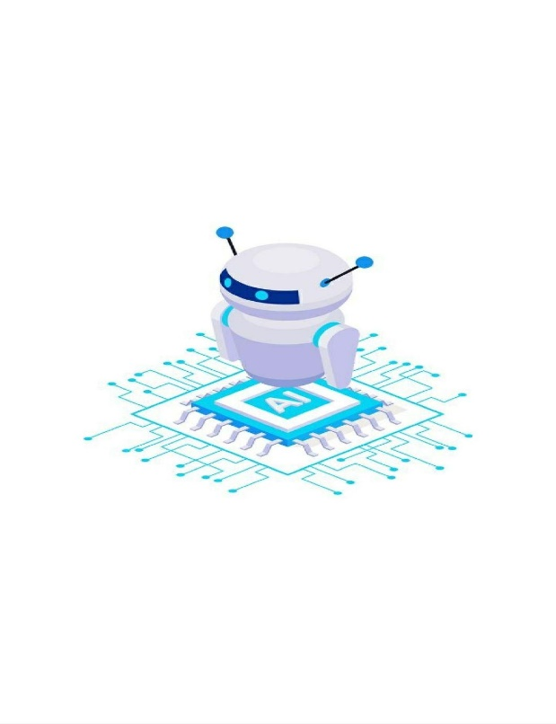  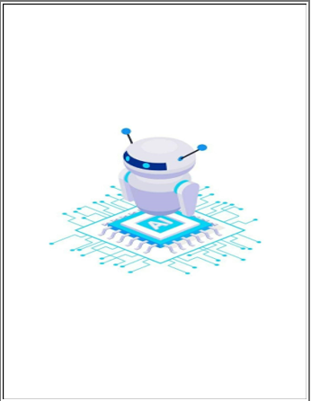  Welcome Page | 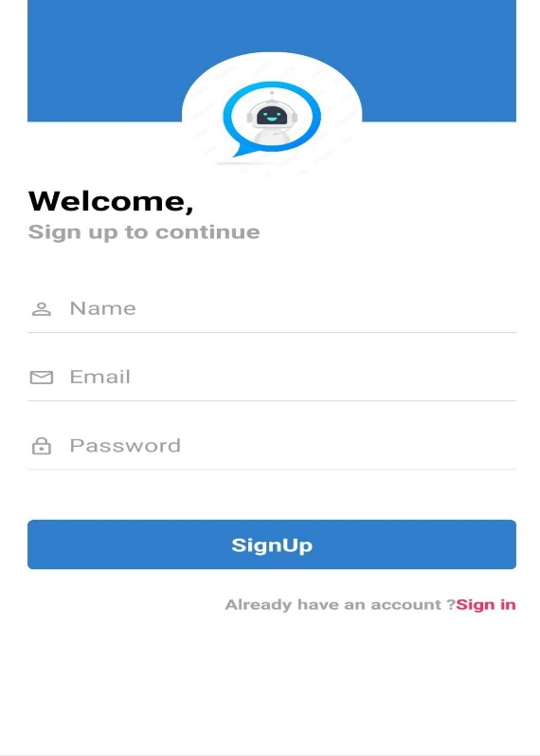  SignUp Page
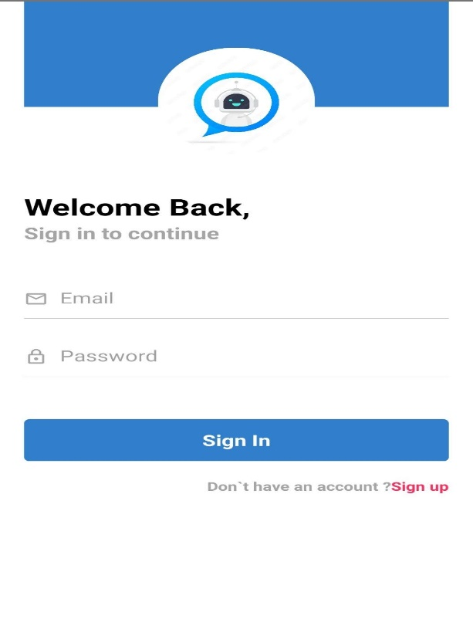  SignIn Page | 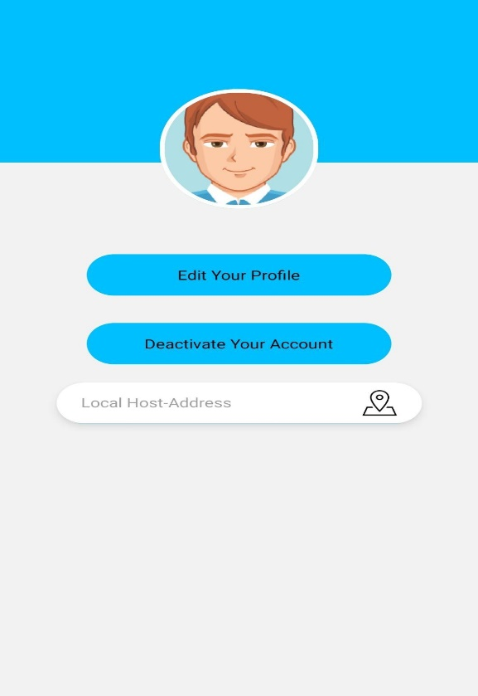  Profile Page

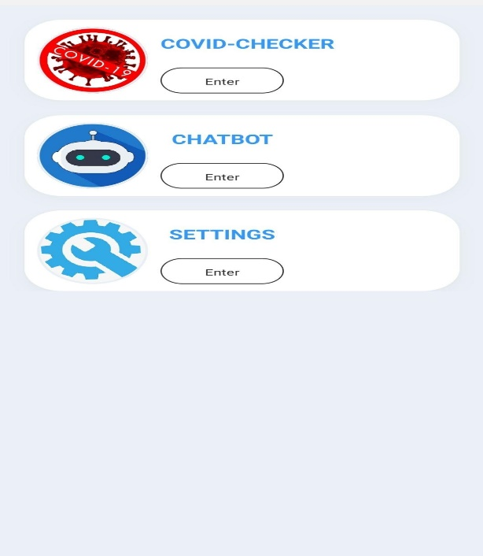  Option Page | 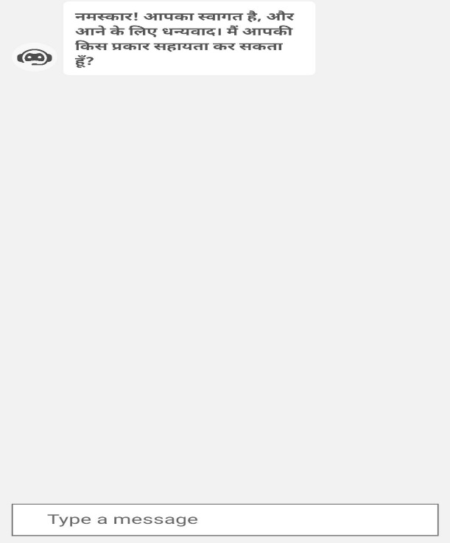  Chat Interface page

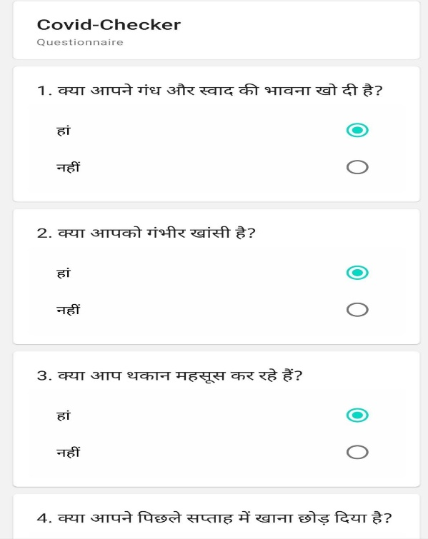  Covid-Checker Screen | 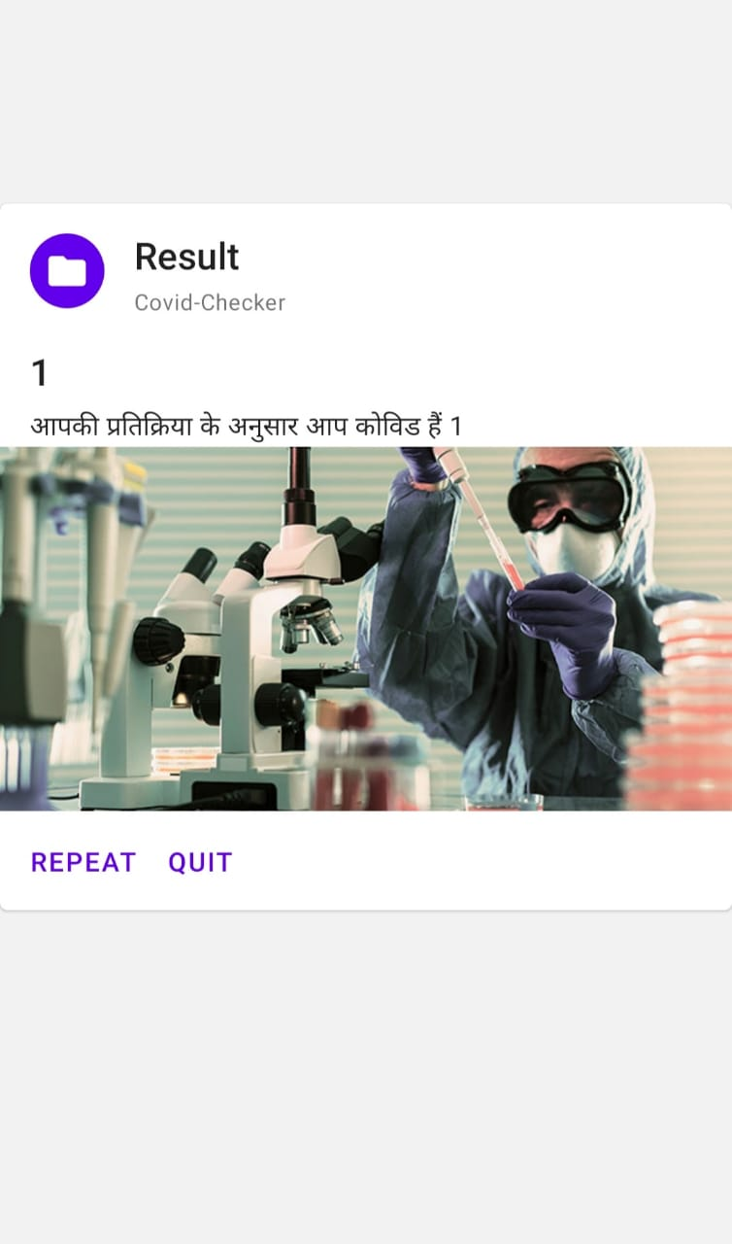  Result Screen

6. CONCLUSION

Chatbots can be trusted assistants who provide users with 24/7 support by answering simple, repetitive questions with pre-programmed responses. This CBT driven Chatbot provides patients with a great user experience by simply having a conversation with the bot to get relevant answers to their questions. The main benefit of using Chatbots with the help of mobile applications and websites is to reach a broad audience. Besides that, this Chatbot platform works positively to provide efficient service in various fields to serve humans in many different and multiple ways. These features make Chatbots useful to spread awareness about COVID-19 [18].

The authors recommend the use of this CBT driven Chatbot for the purpose where it would converse with the user based on the input provided by the user and get the output generated by the system based upon the user's input query. The variety of different questions used in the dataset provides the user an appropriate answer and stands out to be one of the important reasons along with the model used. Previously the authors worked on this project for the English Language and now we are expanding the work of the Chatbot with the Hindi Language. Furthermore, the Chatbot can communicate in both English and Hindi, making the user more convenient talking to it and resolving their queries accordingly. Developing a big and appropriate dataset is also an important task for the Chatbot systems along with models and implementations. The dataset used for this Chatbot was collected from authentic sources, and it manages to cover most of the user queries related to COVID-19 and mental health.

The Transformer model's attention mechanism may be the future of NLP, outperforming the success of RNN. Once the COVID-19 pandemic has passed, we plan to reconfigure this CBT driven Chatbot and make it compatible with other epidemics as well as services by utilizing individual APIs or relevant datasets. The authors intend to increase the Chatbot language design beyond Hindi and English to include many more regional languages, allowing a wider range of users to use the system. People who do not speak English well can use the Chatbot in their chosen language.

REFERENCES

- Nagargoje, S., Mamdyal, V. and Tapase, R., 2021. Chatbot for Depressed People. United International Journal for Research & Technology (UIJRT), 2(7), pp.208-211.
- Bhagwat, V., Nagarkar, M., Pooja, P., Shrikant, J., Kharate, N.G. (2019). Review of Chatbot System in Hindi Language. International Research Journal of Engineering and Technology (IRJET), 6(11), 2395-0072.
- Setiaji, B., & Wibowo, F. W. (2016, January). Chatbot using a knowledge in database: human-to-machine conversation modeling. In 2016 7th international conference on intelligent systems, modeling, and simulation (ISMS) (pp. 72-77). IEEE.
- Badlani, S., Aditya, T., Dave, M., & Chaudhari, S. (2021, May). Multilingual Healthcare Chatbot Using Machine Learning. In 2021 2nd International Conference for Emerging Technology (INCET) (pp. 1-6). IEEE.
- Ouerhani, N., Maalel, A., Ghezala, H. B., & Chouri, S. (2020). Smart Ubiquitous Chatbot for COVID-19 Assistance with Deep learning Sentiment Analysis Model during and after quarantine.
- Ali, A., & Amin, M. Z. (2019). Conversational AI Chatbot Based on Encoder-Decoder Architectures with Attention Mechanism. Artificial Intelligence Festival 2.0.
- Ahmad, N. A., Che, M. H., Zainal, A., Abd Rauf, M. F., & Adnan, Z. (2018). Review of chatbots design techniques. International Journal of Computer Applications, 181(8), 7-10.
- Sojasingarayar, A. (2020). Seq2seq ai chatbot with attention mechanism. arXiv preprint arXiv:2006.02767.
- Dharwadkar, R., & Deshpande, N. A. (2018). A medical chatbot. International Journal of Computer Trends and Technology (IJCTT), 60(1), 41-45.
- Bhirud, N. S. (2017). Grammar checkers for natural languages: a review. International Journal on Natural Language Computing (IJNLC) Vol, 6.
- Shah, A., Shah, R., Desai, P., Desai, C. (2019). Mental Health Monitoring using Sentiment Analysis, International Research Journal of Engineering and Technology (IRJET) ISSN: 2395-0072, Volume: 07 Issue: 07.
- Bharti, U., Bajaj, D., Batra, H., Lalit, S., Lalit, S., & Gangwani, A. (2020, June). Medbot: Conversational artificial intelligence powered chatbot for delivering tele-health after covid-19. In 2020 5th International Conference on Communication and Electronics Systems (ICCES) (pp. 870-875). IEEE.
- George, A. S., Muralikrishnan, G., Ninan, L. R., Varrier, P. S., & Dhanya, L. K. (2021, June). Survey on the Design and Development of Indian Language Chatbots. In 2021 International Conference on Communication, Control and Information Sciences (ICCISc) (Vol. 1, pp. 1-6). IEEE.
- Tewari, A., Chhabria, A., Khalsa, A. S., Chaudhary, S., & Kanal, H. (2021). A Survey of Mental Health Chatbots using NLP. Available at SSRN 3833914.
- Sancheti, R., Upare, S., Bhirud, N., & Tatale, S. Adaptive Machine Learning Chatbot for Code-Mix Language (English and Hindi).
- Rus, V. (2018). Intelligent Chatbot using Deep Learning (Doctoral dissertation, University of Memphis).
- Palasundram, K., Sharef, N. M., Nasharuddin, N., Kasmiran, K., & Azman, A. (2019). Sequence to sequence model performance for education chatbot. International Journal of Emerging Technologies in Learning (iJET), 14(24), 56-68.
- Patil, A., Patil, K., Shimpi, G., & Kulkarni, M. (2020). COVIBOT: An efficient AI-based Chatbot with Voice Assistance and Multilingualism for COVID-19. Department of Information Technology, 17.
- Thukrul, J., Srivastava, A., & Thakkar, G. (2020). DoctorBot-An informative and interactive Chatbot for COVID-19. International Research Journal of Engineering and Technology (IRJET), 7(07), 2395-0072.
- Vanjani, M., Aiken, M., & Park, M. (2019). Chatbots for multilingual conversations. J. Manag. Sci. Bus. Intell, 4, 19-24.
- Kroenke, K., Spitzer, R. L., & Williams, J. B. (2001). The PHQ-9: validity of a brief depression severity measure. Journal of general internal medicine, 16(9), 606–613.
- Suraj, D. M., Prasad, V. A., Mitra, S., Rohan, A. R., & Salis, V. E. (2019). Conversational Assistant based on Sentiment Analysis.
- W. S. Erazo, G. P. Guerrero, C. C. Betancourt and I. S. Salazar, "Chatbot Implementation to Collect Data on Possible COVID-19 Cases and Release the Pressure on the Primary Health Care System," 2020 11th IEEE Annual Information Technology, Electronics and Mobile Communication Conference (IEMCON), 2020, pp. 0302-0307, doi: 10.1109/IEMCON51383.2020.9284846.
- Bhirud, N., Tataale, S., Randive, S., & Nahar, S. (2019). A Literature Review on Chatbots In Healthcare Domain. International Journal of Scientific & Technology Research, 8(7), 225-231.
- Rizvi, M. S. Z., 3 Important NLP Libraries for Indian Languages, 2020. Analytics Vidhya.
- Coronavirus disease (COVID-19) pandemic, World Health Organization (WHO), emergencies, diseases, novel-coronavirus-2019.
- B. Sharma, H. Puri and D. Rawat, "Digital Psychiatry - Curbing Depression using Therapy Chatbot and Depression Analysis," 2018 Second International Conference on Inventive Communication and Computational Technologies (ICICCT), 2018, pp. 627-631, doi: 10.1109/ICICCT.2018.8472986.
- Jain, Priyanka, Subhash Tatale, Nivedita Bhirud, Sanket Sonje, Apurva Kirdatt, Mihir Gune, and N. K. Jain. "8 Psychiatric Chatbot." Machine Vision for Industry 4.0: Applications and Case Studies (2022): 169.

